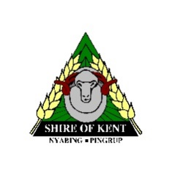

Shire of Kent

**PUBLIC NOTICE**

**DISPOSAL OF PROPERTY**

**S3.58 (3), (4) of the Local Government Act 1995**

**Property:** Lot 12 CT 2061 F733, (16) Richmond St Nyabing (1,012m2)

**Sale Details:** The Shire of Kent gives notice of intention to dispose of the Nyabing General Store by way of private sale.

**Purchaser:** Manj Family Trust

**Purchase Price:** $1 (one dollar)

**Market Value:** $65,000

Submissions in regards to this proposal are to be made in writing to the CEO, Shire of Kent, PO Box 15, Nyabing 6341 by 4.00pm, Tuesday, 8 December 2020.

**Rick Miller  
Chief Executive Officer**